Registration No: 2025/CS/079
Index No: 25000799
Lab Sheet 03
Part 01
A.
1 start with the first order in the list.
2 checks if the order id is equal to ORD4589
3 if yes you have found the order id.
4 if not check whether there are any other orders available in the list
5 if yes select the next one and go back to step 2
6 if not the order is not in the list
B.
1 go to the middle of the list.
2 is the item in the middle has the order id ORD4589
3 if yes you have found the order id.
4 if not compare the order id with the one in the middle
5 if order id is less than the one in the middle choose the new middle from the left part of the list
6 if order id is greater than the one in the middle choose the new middle from the right part of the list
7 if the new middle doesn’t exist, the order id is not present in the list
8 if exists, go back to step 1
-----------------------------------------------------------------------------------------------------------------------
- 8 comparisons
- 44, 56, 78, 89, 105, 132, 176, 210, 250, 305
3 comparisons
-----------------------------------------------------------------------------------------------------------------------

Part 02
- 1. 8 new users
2. 21 new users
- 1 + 1 + 2 + 3 + 5 + 8 + 13 + 21 = 54 users
- 141 new users
- 6th – 8 12th – 144
Growth rate = (144 – 8) = 136
- 54 + 34 + 55 + 89 + 144 = 376 users
- 1, 1, 2, 4, 7, 11
11 > 8. New sequence has more users than the previous one
- 11th and 12th

No of new users are increasing gradually with every month.
-----------------------------------------------------------------------------------------------------------------------

Part 03
- 1 start with the first number in the list.
2 checks if the number is equal to 34
3 if yes z = position.
4 if not check whether there are any other numbers available in the list
5 if yes select the next one and go back to step 2
6 if not z = -1 ( or z = 0 )

No of comparisons : 9

- 1 go to the middle of the list.
2 is the item in the middle is 144.
3 if yes z = position of middle
4 if not compare 144 with the one in the middle
5 if 144 is less than the one in the middle choose the new middle from the left part of the list
6 if 144 is greater than the one in the middle choose the new middle from the right part of the list
7 if the new middle doesn’t exist, z = -1 ( or z = 0 )
8 if exists, go back to step 1

No of comparisons : 2

- A. it searches a list by going from first element to the last. Advantage of this method is that list doesn’t have to be sorted for the operation to work. Disadvantage is that it will make many comparisons to find the number relative to binary search.

B. it searches the list by first dividing it into two parts from the middle. If the searching item was not at the middle it goes to the part where the item is most probably at and use the same method until it finds the item or until the list cannot be divided any more. Advantage of this method is that it makes less comparisons to find the number. Disadvantage is that it will only work if the list is already sorted.

- 1 follow steps in II. to find the month that has 21 new users. (m1)
2 follow steps in II. to find the month that has 233 new users. (m2)
3 range of the months can be calculated using m2 – m1

-----------------------------------------------------------------------------------------------------------------------
Part 04
Binary Search
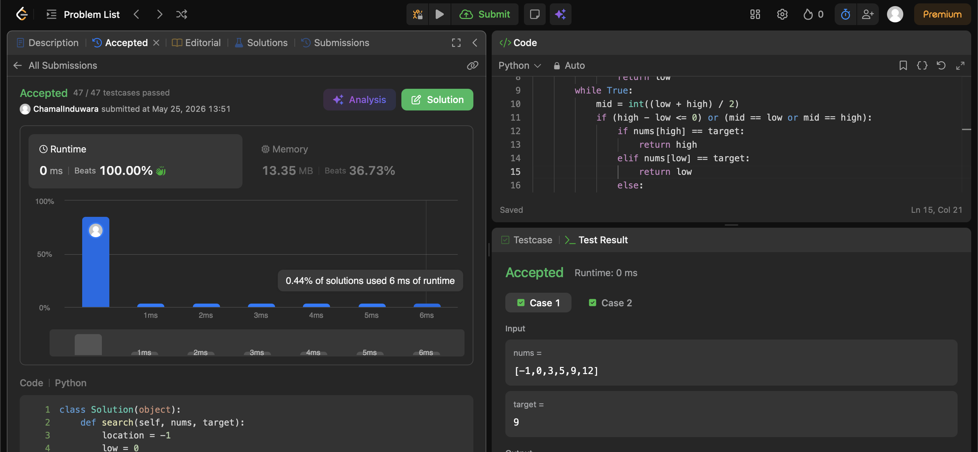
Fibonacci number
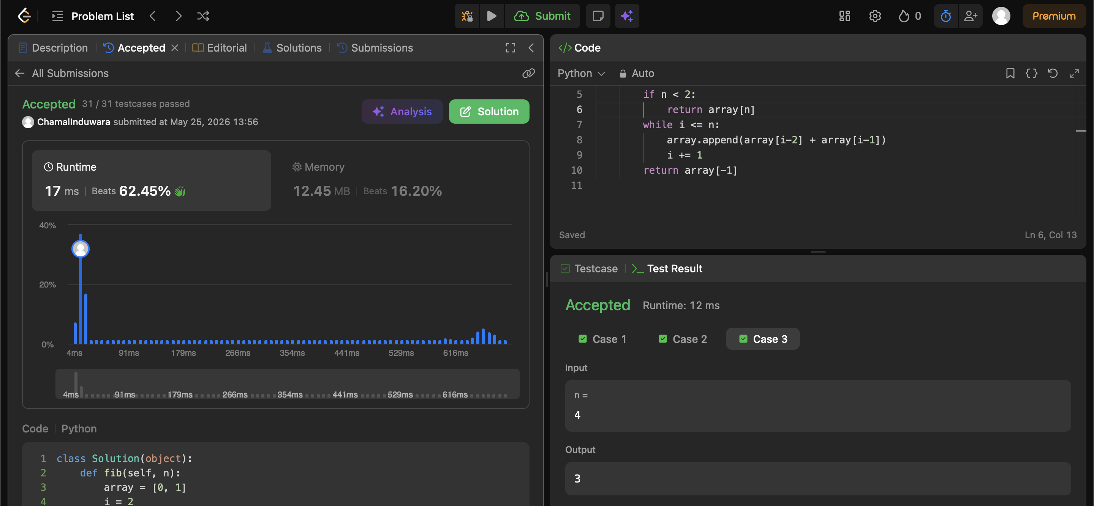

Search Insert Position
